Export Knowledge Programme
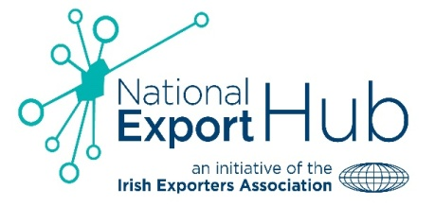 In partnership with

Introduction
The National Export Hub in partnership with InterTradeIreland is delighted to announce the launch of a new initiative called the ‘Export Knowledge’ programme. This is a two-phase programme which aims to take participants through an educational and support led journey to improve their capability to export into existing and/or new markets on the Island of Ireland and internationally.
In addition;
InterTradeIreland has developed a number of programmes to assist SME’s to develop their capability to export on a cross-border basis. Participants on this programme will be able to avail of the services offered by InterTradeIreland to identify new cross-border opportunities on the island of Ireland.
Following submission of an application form and satisfaction of the basic eligibility criteria, the programme will be structured as follows:
Phase 1 – Export Readiness Assessment
An initial Export Readiness assessment will be carried out on your business. The purpose of this process is to ensure that your business has the required organisational structure, culture and resources to support growth and entry into new export markets. This may involve a visit to your premises for a review and assessment of the following areas:
Product/Service Range | Capacity to Scale
Export Market Knowledge | International Sales Competency
Management Commitment | Current sales and marketing practices
Distribution structure and routes to market

Subject to a successful outcome to the export readiness assessment, your business will be selected to participate in phase 2 of the programme. If your business is not chosen to participate in phase 2, you will receive a report with an assessment of your export readiness, together with advice and action points on how to improve your ability to enter export markets at a future date.

Phase 2 – Export Workshops

This phase comprises the learning/mentoring component of the programme. Each business will participate in six/seven full day Export workshops during which time they will learn about:
Workshop 1: Selection and Management of Channel Partners/Distributors.
Workshop 2: Knowledge of International legal, contract and IP issues.
Workshop 3: International financial management, cost control, quality assurance, financial risk management.
Workshop 4: E-commerce skills and social media skills, marketing mix skills.
Workshop 5: International Logistics (air, sea, rail, road), order administration.
Workshop 6: Awareness of customer needs in different markets, knowledge of international design standards and codes.
Workshop 7: Awareness of All-Island Public sector Tendering Opportunities.

Participate in two themed roundtables providing an opportunity for networking and knowledge sharing.
The final programme of workshops will be determined by the export ready audit findings. It is envisaged that these workshops will occur once a month over a seven month period.
Phase 3 – Review and Final Evaluation
The final phase will measure and evaluate the outcome of the mentoring / learning achieved through the programme. This process will establish what stage of the export glide path each business is at, the potential for future export growth and the increase in sales in current or new export markets.

Application Process:
Applications and details of eligibility criteria can be obtained from the Irish Exporters Association or InterTradeIreland and must be returned by Friday 30th September.
Export readiness assessments will likely take place during the month of October. Workshops will commence November 2016.
For further information, please contact:
Sinead Branigan
Irish Exporters Association
Tel: +353 (0)1 661 2182
Email: sineadbranigan@irishexporters.ie

Paddy Savage
InterTradeIreland
Tel: 028 3083 4110 (048 from Ireland)
Email: paddy.savage@intertradeireland.com

